课题 | 译林版七年级Unit 7 Outdoor fun-Pronunciation 教学设计
课型 | 新授课 | 主备人
一、教学目标
通过本课时的学习，学生能够:
- 听录音并跟读单词，获取和归纳规则动词的过去式中-ed的发音规律；
- 运用规则动词的过去式中-ed的发音规律，准确拼读单词，朗读介绍户外活动经历的语篇；
- 运用准确的发音谈论户外活动经历，进一步理解户外活动的价值和意义。
二、教学重难点
1. 教学重点
学习规则动词的过去式中-ed的发音。
2.教学难点
学会运用一般过去时描述过去的户外活动经历，并关注-ed的发音准确性。
三、教学方法
1. 任务型教学法：通过设置各种任务，如回答问题、完成笔记、对话练习、写作等，让学生在完成任务的过程中掌握语言知识和技能。
2. 情景教学法：创设真实的户外活动情景，让学生在情景中感受和运用语言。
3. 合作学习法：组织学生进行小组合作学习，共同完成任务，培养学生的合作精神和交流能力。
四、教学过程
（一）示标
Show the learning objectives:
1.Read after the tape,matser the pronunciation rules of -ed in simple past tense;
2.Spell the words correctly with the pronunciation rules;
3.Talk about the outdoor experiences, and better understand the value and meaning of the outdoor activities.
（二）复习巩固已学音标（元音和辅音）
1. 元音：vowel sound(20个)
/ɑ:/ /ɔ:/ / ɜ:/ /i:/ /u:/
/ʌ/ /ɒ/ /ə/ /ɪ/ /ʊ/ /e/ /æ/
/eɪ/ /aɪ/ /ɔɪ/ /ɪə/ /eə/ /ʊə/ /əʊ/ /aʊ/
2. 辅音：consonant sound(28个)
/p/ /t/ /k/ /f/ /θ/ /s/
/b/ /d/ /g/ /v/ /ð/ /z/
/ʃ/ /h/ /ts/ /tʃ/ /tr/
/ʒ/ /r/ /dz/ /dʒ/ /dr/
/m/ /n/ /ŋ/
/j/ /w/ / ǀ/
- 读例句感知规则动词过去式-ed发音
1.The kite started to come down.
2.He decided to do hiking.
3.Luckily,a driver stopped and told us which way to go.
4.We cycled for another hour and then arrived at the village.
5.We followed the map on my phone,but it did not give enough details about the countryside.
6.After lunch,we walked around and saw all kinds of interesting flowers and plants.
并提问：How many ways are there to pronounce the -ed ending?
学生作答：There are 3. They are /t/,/d/and/Id/.
（四）听读并总结规律
Many verbs in the simple past tense end in the letters -ed.There are 3 different
ways of pronouncing this ending:/t/,/d/and/Id/.
Read after the tape and summarize when to pronounce /t/,/d/and/Id/.
Summary:
1.If the word ends with a voiceless consonant sound,the -ed is pronounced as__________.
2.If the word ends with a voiced consonant sound or a vowel sound,the -ed is pronounced as __________.
3.If the word ends with /t/ or /d/,the -ed is pronounced as _________.
①清后/t/ ②元浊后/d/
③/t/,/d/ 音后发/ɪd/
（五）练习
1.Read the following words and write an S if the -ed endings in the same group
are pronounced the same and a D if they are pronounced differently.
- opened stopped ( )
- 2.wanted hated ( )
- washed planned ( )
- turned passed ( )
- helped finished ( )
- studied listened ( )
- asked played ( )
- lived stayed ( )
2.Listen to the recording of the words in Part A and write /t/,/d/and/Id/
in the blanks.
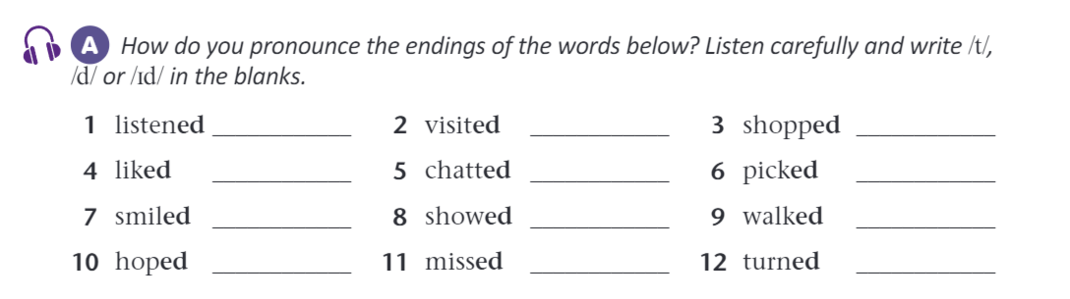
3.Read the text below and try to pronounce the -ed endings of verbs in the simple
past tense.Then listen and check if you are right.
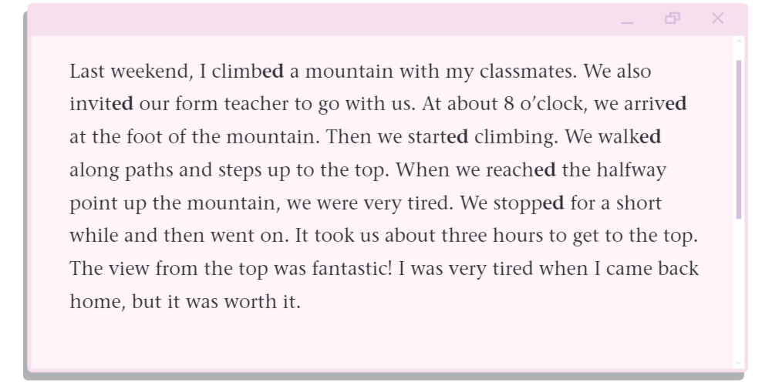

（六）对话练习
Talk about one of your outdoor experiences in pairs and then share it with
the whole class, focusing on the correct pronunciation of -ed.
A:What was your weekend like?
B:It was exciting and fantastic.
A:How did you spend your weekend?
B:I went camping with my parents.We started /Id/putting up the tent in the afternoon.Then we cooked/t/ food and told stories.When it got dark,we stopped/t/ and looked/t/ at the stars.We really enjoyed/d/ the peaceful night.
Use the conservation above as a model and make up a conversation with your partner.
（七）总结与作业布置
1. 与学生一起回顾本节课所学的重点内容。
2. 布置作业：
1.Review the pronunciation rules of -ed in simple past tense;
2.Spell the words correctly with the pronunciation rules;
3.Talk about the outdoor experiences with your classmates and focus on the correct pronunciation of -ed.
五、教学反思
在教学过程中，要充分发挥学生的主体作用，让学生通过自主学习、合作学习等方式掌握知识和技能。同时，要注重对学生语言运用能力的培养，多提供实际的语言环境，让学生在实践中提高英语水平。此外，对于学生在学习过程中出现的问题和错误，要及时给予反馈和纠正，帮助学生不断进步。

