课题 | 译林版七年级Unit 7 Outdoor fun-Reading 2 教学设计
课型 | 新授课 | 主备人
一、Teaching aim
By learning this lesson，students can
- Retell Simon's cycling trip
- Master the language points of important words and phrases and use them to finish the exercises.
- Teaching key&difficult points
1. Teaching key points
Retell Simon's cycling trip
Master the language points of important words and phrases and use them to finish the exercises.
- Teaching difficult points
Retell Simon's cycling trip
Master the language points of important words and phrases and use them to finish the exercises.
- Teaching procedures
- Revision
Let students retell Simon’s cycling trip according to the tips. And review the structure of a narrative diary
- Exercise
Finish the exercise about horse riding and hiking with the given words.
- Language points
List some important words especially the new words and teach their main usage. Let students take notes and do some corresponding exercises.
Experience C.n. 经历 an unforgettable experience 一次难忘的经历
U.n. 经验 have experience in doing sth 做某事有经验
a teacher with ten years’ experience 一位有着十年经验的老师
V. 体验 experience the charm of Chinese culture 体验中国文化的魅力
adj. experienced 有经验的 an experienced teacher 一位有经验的老师
Set off 出发，动身，启程
燃放 set off fireworks 燃放烟花
set up 建立 set up a company 建立一个公司
set out 出发，动身；开始
set aside 留出（时间或金钱）； 不顾，不理会
a set of 一套，一组
Follow v. 遵循 follow the rules 遵守规则
v. 跟随 follow in the footsteps of sb 跟随某人的脚步
follow the heart 跟随内心
v.跟踪
following adj. 接下来的，之后的
detail n. 细节；具体情况 in detail 详细地
detailed adj.详细的
lost adj.迷路的 get lost 迷路
adj.丢失的 the lost key 丢失的钥匙
*lost和missing的区别：
lost指永久性消失，无找回可能，missing是暂时消失，可能找回
lost是动词lose的过去式和过去分词
lose v. 丢失，失去；输掉 lose one’s way=get lost 迷路
lose weight 减肥 lose ccontrol 失控
lose heart 失去信心 lose face 丢脸
loser n.失败者
none pron.没有一个
none表示三者或三者以上的人或物一个也没有
none可以指代可数名词，也可以指代不可数名词，做主语时，若指代不可数名词，谓语动词用单数，若指代可数，谓语动词可单可复
none可以和of连用，后面加复数名词
worried adj. 担心的，发愁的 be worried about sb/sth 担忧某人/某事
worrying adj. 令人担忧的
worry U.n 担忧 c.n. 令人担忧的事情 （p.l.worries）
worry vt.使…担忧 Tom always worries his parents.汤姆总是让他的父母担忧
worry vi. 担忧 worry about sth/sb 担忧某事/某人
Tom always worries about his old parents.汤姆总是担忧他年迈的父母
luckily adv. 幸运地 反：unluckily 不幸地
lucky adj. 幸运的 You‘re lucky to live in such a nice neighbourhood.
unlucky adj.不幸的
luck u.n 运气 Wish you good luck
arrive vi. 到达 arrive in+大地点 arrive at+小地点
arrive in/at=get to=reach 到达
Find out vs. find
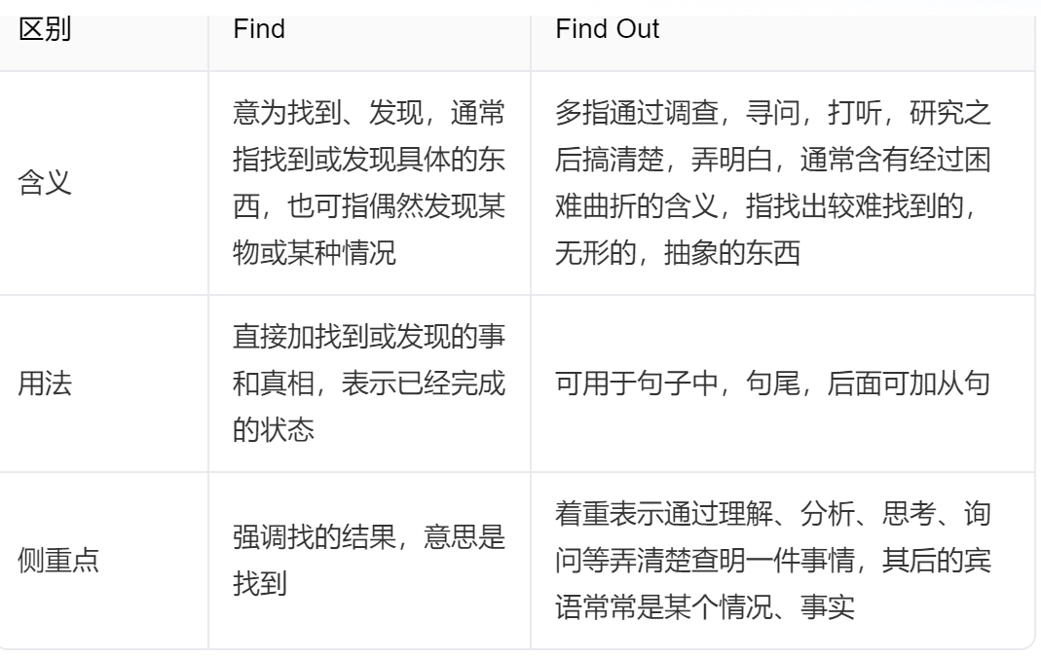
proud adj. 骄傲的，自豪的 be proud of 为…感到骄傲，自豪
pride n.骄傲，自豪 take pride in 为…感到骄傲，自豪
proudly adv. 骄傲地，自豪地
can’t wait to do 迫不及待去做某事
区分： can’t help/stop doing 情不自禁做某事，忍不住做某事
- Exercise
Let students finish all the exercises
- Homework
- Remember the language points.
- Finish the corresponding exercises
- Introduce Simon’s cycling trip according to your poster to your parents or friends.
教学反思：

