课题 | 译林版七年级Unit 7 Outdoor fun-Reading 1 教学设计
课型 | 新授课 | 主备人
一、Teaching aim
By learning this lesson，students can
- Introduce Simon’s cycling trip and understand the meaning of cycling or outdoor activities.
- Tell the features of a diary and how to write a diary
- Write their own diary of an experience
- Teaching key&difficult points
1. Teaching key points
Let students retell Simon’s cycling trip and say the meaning of cycling and outdoors
Make students tell the features of a diary
- Teaching difficult points
Make students say the meaning of cycling and outdoors and know how to write a diary
- Teaching procedures
- Revision
Review the welcome part and let students come into the class quickly
- Lead-in
Share a video about cycling with students and ask some questions. Lead in today’s topic--cycling. Simon likes cycling too. He wrote a diary about cycling.
- Read for title
Ask students to read the title and the entry. Then let them tell the main idea and the type of the article. And ask them where they find the answer. Underline the key words.
Then ask students if they write diaries. If they write a diary, what will they write about?
Then point out the necessary elements: time(when),place(where),character(who),event(what),feelings(how) and weather
- Read for basic information
Let students read the diary quickly and find the necessary elements. After the time and weather, give a tip of the feature of the diary.
When it comes to feelings, students may only find “amazing”. And teachers can let them continue finding. Then give a tip of reading: we should pay attention to the first and last paragraph
- Read for structure
Since the first and last paragraph are read, the structure of the article is obvious.
Let students choose the right structure.
And then summarize the main idea of each paragraph
Any narrative diary can be written in such a form.
- Read for details
①Let students read para 2-5 and fill in the table to learn about the whole process of the trip.
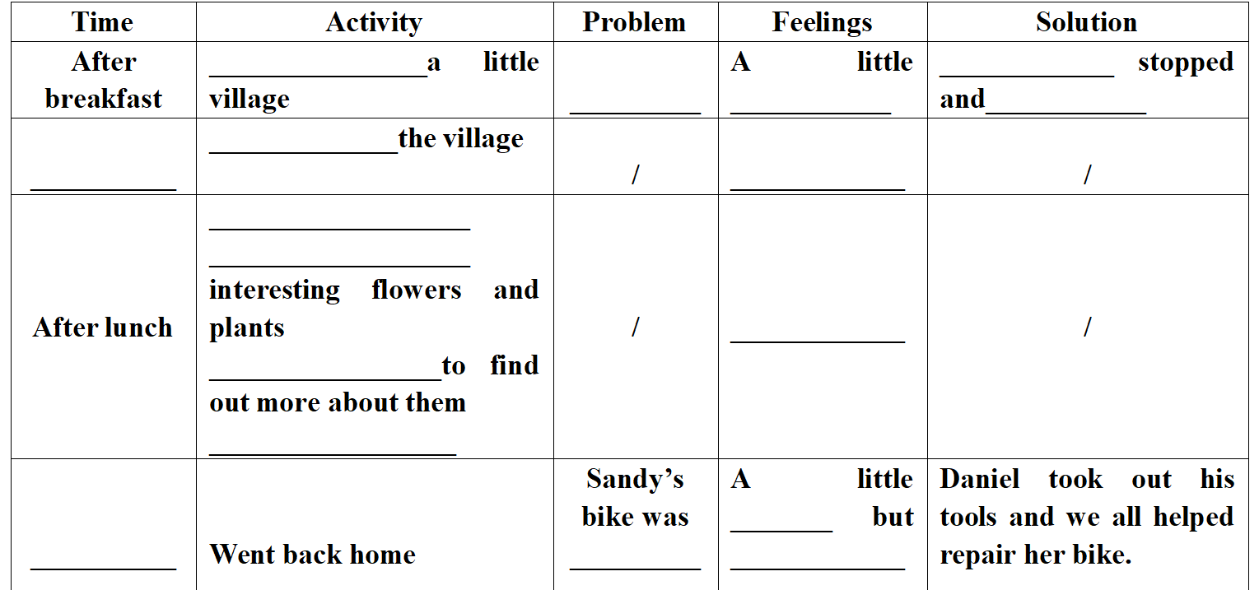
Then finish the exercise on the book. Put the sentences into the right order.
②further thinking
- Why did they choose the village ?
- What might they take when cycling?
- What else should we take when going on a trip?
- Why did they get lost?
- If you have trouble during the trip, what will you do with it?
- What will you get from their experience?
③Discussion
Discuss with your partner and give some advice on safety.
Teachers should teach students to pay attention to safety when outing.
- Read for language
According to the table,ask students:
- How does Simon develop his diary?---In the time order
- Look at all the verbs, what can you find?--Simple past tense.
(give students a tip of the feature of the diary.When we write a diary, we can develop it in the time order and we need to use the simple past tense since it has happened.)
- Except the adjectives, can you find other expressions showing Simon’s feeling?
Find the sentences and then read. Give the tip(When we describe our feelings, we can use some adjectives and some punctuation marks, such as “!” or “?”.)
Let students brainstorm some adjectives that describe people’s feelings?(when writing, students can use them and avoid repeating.
- Read for theme
What do you think of Simon’s cycling trip? Why?
What can Simon learn from this cycling trip?(if students can’t answer, teachers can give some hints)
What’s the meaning of cycling or outdoor activities?
(first, summarize Simon’s cycling trip. Then linked to the unit title. Share a video about the meaning of cycling and then let students tell the meaning of cycling. They are also the meanings of outdoor activities.)
- Summary
What do we learn today?--A diary of Simon’s cycling trip
How does Simon write his diary?--呈现汉堡包图形和文章内容结构
Summarize all the tips above
Then teach students if we write a diary, we can follow this model.
- Read for writing
Write a diary entry about an outdoor activity. If you can’t finish it because of time limit, you can make a table first as follows.
- Homework
Must to do
1. Make a poster about Simon’s trip
2. Finish and polish your diary
Choose to do
Make a vlog about your trip and post it online
教学反思：

