教学设计
课程基本信息
学科 | 英语 | 年级 | 七年级 | 学期 | 春学期
课题 | Unit 6 Beautiful landscapes (Integration D)
教科书 | 书 名：《义务教育教科书·英语》七年级下册  出版社：译林出版社 出版日期：2024年12月
教学目标
1. 阅读丹尼尔的文章，在表格中填写所选景观的相关信息；
2.在写作活动中综合运用本单元词汇知识与表达以及语篇结构知识与表达，完成一篇介绍一个美丽或者有趣的中国地貌景观的文章，多角度描写和介绍中国斑斓多彩的地貌景观，表达对自然的热爱和敬畏之情，积极宣传祖国的大好河山。
3. 提高保护自然地貌，自然景观的意识。
教学内容
教学重点：1. 理解并准确表达不同景观的比例和特点。
- 写一篇关于自然景观的文章，清晰地表达自己的想法。
教学难点：运用所学词汇和句型准确、流畅地描述景观；对复杂的景观信息进行概括和整合。
教学过程
Step 1. Lead-in
- Show students different pictures of landscapes.
Let’s take a visual tour around the world. Do you know the names of the landscapes?
2 Have a guess.
Can you guess what kind of landscape this is?
3 Have students answer the questions in Part A.
Step 2. Presentation
- Have students answer the following question.
If you want to write an article about a beautiful or an interesting landscape in China, what information about the landscape would you mention?
Daniel is making a table about a landscape. Ask students to read the table and complete it with the information about the landscape they choose.
 | Daniel | Me
What it is | Mount Huangshan
Where it is | In the south of Anhui province
What it is famous for | Pine trees and rocks in strange shapes ;a sea of clouds; hot springs
What you can do there | Get to the top to see an amazing view; enjoy the view at sunrise or sunset
- The teacher asks students to read Daniel's article about an interesting landscape and answer the questions.
Where is Mount Huangshan ?
How high is Mount Huangshan?
What is Mount Huangshan famous for ?
When does it become a white wonderland?
What can you do/see there?
- The teacher asks students to analyze the structure of the article.
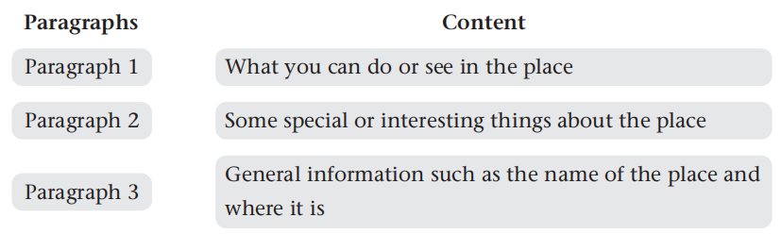
- Learn some language points of the article.
Step 3. Practice
- Write an article about a beautiful or an interesting landscape in China based on the information in Part D1. Use Daniel's article as a model.They can refer to Part D1 on page 77 and Part D2 and D3 on page 78 for ideas about structure, content and expressions.
- some mind maps for reference.
- Some tips for writing:
Tip 1 sentence expansion(扩写）
It's + adj. +(for sb.) to do sth.
One of + 最高级+名词复数+谓语动词单数
not only ... but also ...
Tip 2 Linking words
顺序 ：①first, firstly, first of all, at the beginning,
②secondly, thirdly, then, besides, what’s more, in addition, after that, meanwhile(与此同时),
③finally, last but not least, in the end ...
Step 4. Assessment
- Have students check their writing after they finish and exchange drafts with their partners for review. Then have students revise their articles.
Jiuzhaigou Valley: A Beautiful Place in Sichuan
Jiuzhaigou Valley is in the north of Sichuan Province. It is a famous place known for its amazing nature. Many tourists visit Jiuzhaigou to see its beautiful views.
Jiuzhaigou has clear blue lakes, tall waterfalls, and snowy mountains. The lakes are colorful, and in autumn, the leaves on the trees turn bright colors. In winter, the valley looks peaceful and white with snow. It is also home to many rare animals and plants.
When you visit Jiuzhaigou, you can walk on paths or take a bus to explore the valley. Many people stay in nearby towns to enjoy the beauty of the place. The sunrise and sunset views are very special, making it a perfect place to relax.
- let’ s enjoy a video. What can you see in the video? How do you feel?
Landscapes are treasures of nature, we need to have an eye to capture beauty and have a heart to protect beauty.
Step 5 Homework
1. Make a video to introduce your favourite landscape and tell us why.
2. Make a graphic organizer about the earth’s landscapes based on what you have learnt in this unit.

