课题名称 | 7BUnit 5 Animal friends ---welcome to the unit课时教学设计
语篇类型 | 听说课
授课时长 | 40分钟
语篇研读 | What---课文的重点是动物的事实，包括蝙蝠、蝴蝶、蜜蜂和蚂蚁。它通过米莉和西蒙之间的配对活动和对话来呈现关于这些动物的有趣信息。目的是在提高学生的阅读能力和词汇量的同时，教会学生不同动物的一些独特特征。  Why---课文的目的是教给学生各种动物知识，培养他们对自然界的好奇心和兴趣。课文鼓励学生之间通过对话进行合作和交流，促进团队合作和课堂参与。课文还强调了观察和批判性思维在学习动物时的重要性，以及与他人分享知识的价值。  How---图文结合是为了呈现动物事实，让学生将事实与正确的动物相匹配，从而让学生参与到学习中来。此外，它呈现了米莉和西蒙之间的对话，作为学生讨论他们的动物知识的指南。这种方法有助于培养学生的听说能力，同时了解动物的能力。
学情分析 | 【已知】学生在小学阶段已经接触过一些常见的动物，如bat, butterfly, honeybee, ant, insect等，具备一定的基础词汇量。  【未知】对于一些与动物行为有关的单词，如wing, taste, awake, up to, lift, weight等，可能不太熟悉；对于如何用英语准确谈论自己喜欢的动物可能存在一定的困难。  【能知】通过学习文本，学生能够掌握相关的词汇和句型，能够用简单的英文句子描述自己了解的动物事实和能力，能够表达自己对动物的了解和看法，提升语言运用能力和思维能力。
教学目标 | 通过本课学习，学生能够：  1、借助图片和文本，获取、识记和理解描述动物的词汇和语言表达；  2、借助对话和音频，获取并梳理关于动物的信息，提取和归纳介绍动物、表达自我感受的词汇和语言表达；  3、运用相关词汇和语言表达，开展同伴问答活动，相互交流自己熟悉的动物知识并表达感受。
教学评一体的教学设计
教学目标  学生能够根据图片识别和理解与动物相关的词汇、短语和句型，能够理解与动物相关的简单描述和对话。  用实践：  学生能够运用所学的语言知识，进行对话，模拟关于动物事实和能力的对话，提高语言表达能力和交际能力。  迁移创新：  学生能够运用所学的词汇和句型，完成表格题，巩固对动物相关表达的掌握。同时，谈论知道的动物。  帮助学生梳理本节课的知识体系，加深对重点知识的记忆和理解，培养学生自主总结和归纳知识的能力，引导学生形成系统的学习方法和思维方式，为后续学习奠定基础。 | 学习活动  Step 1: Warming-up  1.Have students talk about their friends.  - Do you have friends？  - Do you have an animal friends?Who are they?  - Have students look at the pictures on page 56 and answer the following questions.  - What animals can you see in the picture?  - Which animal do you like best? Why?  - Have students read the unit overview on page 56 and answer the following question.  - What will we do in this unit?  Step 2: Presentation  1. Present the new words and phrases through pictures and explanations. For example, show a picture of a bat and say, "This is a bat. Bats have wings and they find their way by listening."  2. Display the four animal facts and the pictures of the four animals (bat, butterfly, honeybee, ant) on the PPT. Ask students to read the facts carefully and try to match them with the right animals.  3. Check the answers and explain the reasons. For example, for the fact "They have four wings. They taste things with their feet.", show a picture of a butterfly and explain how butterflies have four wings and use their feet to taste.  Step 3: While-listening  1.Have students listen to Millie ans Simon’s conversation in Part B on page 57 and complete the table.  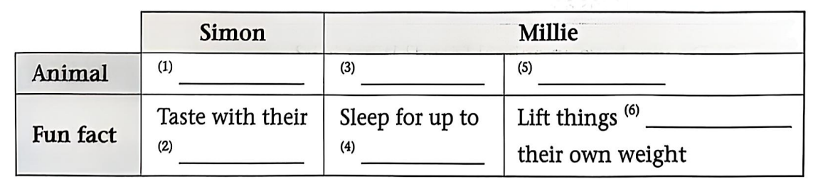  2.Have students read the conversation in Part B and find out the expressions that show the speaker’s feelings.  3.Have students read the tip in Part B and explain why the expressions are used。（to express surprise, excitement, or interest）  4.Have students come up with more expressions to show one’s feelings.  Step 4:Post-listening  1. Ask students to work in pairs and have similar conversations about the animal facts they know.  A: What facts about animals do you know?  B: I know ...  A: That’s ... Do you know that ...?  B: Really? That’s ... What else do you know?  A: I know ...  B: Wow! ...  2.Group work.  Enjoy a video and have students work in groups ,interview their group members using the questions in Part C on page 57 and complete the table below.  What other fun facts about animals do you know?  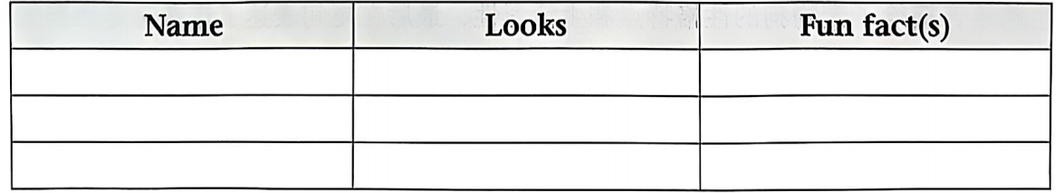  3.Have students report the fun facts about animals they know.  S1：I want to share something about ... with you.  They have ....They can/can’t...  Step 6:Summary  1. Summarize the key points of this lesson, including the vocabulary and sentence patterns about animal facts.  2. Assign homework: Ask students to search for more fun facts about animals and write them down. They can also prepare to share them in the next class. | 设计意图  Attract students' attention and arouse their interest in the topic of animals.  Help students learn about the fun facts about animals  Introduce the theme of animals into real-life situations, and let students participate in the upcoming buddy activity.  Enhance students'  learning ability and thinking skills.  Encourage the students to share their own thoughts and animal facts. | 效果评价  观察学生是否能够正确理解问句并能够说出相关动物的事实和能力，如I like ...best because ......等。  观察学生能否回答关于动物名称和动物事实匹配的问题，并能够理解和抓住描述句子中的关键信息。  观察学生是否能够流畅地进行对话，准确表达自己知道的动物事实和能力，以及使用所学的词汇、短语和句型。  根据学生回答的准确性和完整性判断其对听力材料主题的理解能力，引导学生在回答后简要说明判断依据，进一步考察其听力理解思维过程。  观察学生是否能够正确理解听力原文细节，能够对比和总结不同动物的习性等。  巡视各小组交流情况，观察学生是否能熟练运用所学句型和词汇进行表达，是否能够积极回应对方并展开有意义的对话。随机抽取几组学生进行对话展示，从表达准确性、流畅性、内容丰富度和互动性等方面进行评价和反馈。
作业设计  （必做） | Preview the poems on Page 58 and think about what pets people keep.
作业设计  （选做） | Search for more names about the pets people have.

